**Batch: A1 Roll No.: 16010121045**

**Experiment / Assignment / Tutorial No. 8**

|  |
| --- |
| **Title: Time Series Models** |

**Objective:** The objective of this lab experiment is to perform time series forecasting using Excel. The goal is to understand the basic principles of time series analysis and apply them to predict future values based on historical data.

**Expected Outcome of Experiment:**

CO4: Analyze the systems for input modeling and validation.

CO5: Estimate the different parameters of absolute and relative performance of different simulation systems.

**Books/ Journals/ Websites referred:**

1. “Discrete-Event System Simulation” by Jerry Banks, John S. Carson II, Barry L. Nelson, David M. Nicol.
2. SimPy Documentation: https://simpy.readthedocs.io/en/latest/
3. SciPy Documentation: https://docs.scipy.org/doc/scipy/

**Background:**

*(Explain in brief Time series models Autoregressive order-1 AR (1), Exponential AR – EAR(1 and ARIMA models.*

**Problem Statement:**

* Obtain historical time series data relevant to your area of interest. For example, monthly sales data for the past few years, or Energy consumption, or Predicting sales or demand in inventory management, or Forecasting stock prices or economic indicators, or Estimating future load in traffic management systems.
* Clean the data by handling missing values and outliers.
* Create a time series plot to visualize the data.
* Decompose the time series data into its components: trend, seasonal, and residual.
* Use Excel’s built-in functions or manually create moving averages to identify trends.
* Calculate moving averages (e.g., 3-month, 6-month) to smooth the data and identify trends.
* Apply exponential smoothing to forecast future values. This method gives more weight to recent observations.
* Use Excel’s function for exponential smoothing and Excel’s Built-in Forecasting Tools. Utilize Excel’s Data Analysis Tools for time series analysis.
* Generate forecasts and plot the results.
* Compare the forecasted values with the actual values using error metrics like Mean Absolute Error (MAE) or Root Mean Squared Error (RMSE).
* Create a new line chart to visualize both the historical data and the forecasted values.
* Highlight the forecast period to clearly distinguish it from the historical data.
* Discuss the reliability of the forecasting method used and any limitations encountered.

**Implementation Steps with Screen shots:**

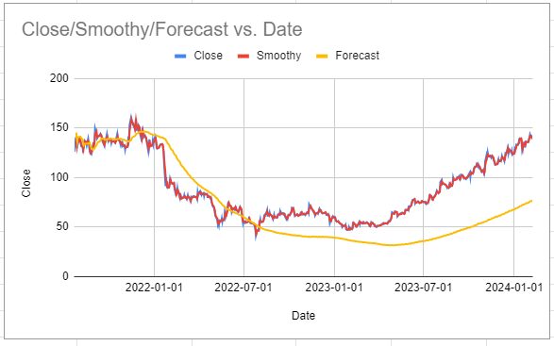

**Conclusion:**

In this time series analysis, we successfully forecasted stock prices using exponential smoothing techniques in Excel. By first cleaning the data and visualizing it, we decomposed the time series into its components—trend, seasonal, and residual. Moving averages were applied to identify trends, and exponential smoothing gave more weight to recent observations, allowing for more accurate forecasting. The performance of the forecast was evaluated using error metrics, with a Mean Absolute Error (MAE) of 25.48 and a Root Mean Squared Error (RMSE) of 32.03. These values indicate that while the model captures the overall trend, there are still some deviations in predictions.

The forecasting method was effective for short-term predictions but may be limited by factors such as insufficient historical data or sudden market volatility. Future improvements could include refining the seasonal component and exploring more advanced models to enhance prediction accuracy.

**Post lab Questions:**

1. **What is the difference between ARIMA and AR models? When would you choose one over the other?**

AR Model: Predicts future values based on a linear combination of past values (lags). Use AR when the data is stationary.

ARIMA Model: Combines autoregressive (AR), differencing (I), and moving average (MA) to handle both stationary and non-stationary data. Use ARIMA for data with trends or seasonality.

1. **Explain with example following models:**

* **Seasonal ARIMA (SARIMA) Model**

**SARIMA** extends ARIMA to handle seasonality. It incorporates seasonal differencing and seasonal autoregressive/moving average terms. It’s suitable for time series data with both trend and repeating seasonal patterns (e.g., monthly sales data with yearly seasonality).

* **Holt’s Linear Trend Model: For data with a trend.**

Holt’s Linear Trend is used for time series data with a linear trend but no seasonality. It extends simple exponential smoothing by adding a trend component, making it useful for forecasting data with a consistent upward or downward trend over time.

* **Holt-Winters Seasonal Model: For data with trend and seasonality.**

Holt-Winters Model includes trend and seasonal components. It’s useful for forecasting data with both a linear trend and seasonality (e.g., monthly sales data with a yearly seasonal pattern). It adjusts for seasonality, trend, and level in the forecasts.